The Smoking Machine
吸烟展示机

Thank you for your time. I understand your perspective, and wish to give you more detail, as the centerpiece of the exhibit is an experiment any school science department can do.
感谢您的时间，我了解了您的意思，希望可以给您提供更多的细节。作为这个禁烟展的核心展示物，是一个任何学校的科学课都可以进行的小实验。
The attached article is from the Bao’an Daily, and documents my first introduction of the smoking machine in Shenzhen.
附件中的文章来自《宝安日报》，记录了我首次在深圳做禁烟宣传的经过。
I developed the system (“invented” may be too strong a word) in 1967, and recently have experienced some remorse at not having promoted it until now, as it very well might have saved many lives: many smokers and young would-be smokers turn away from smoking when they can physically see the day to day consequences of smoking, which is what this machine demonstrates.
我于1967年开发了这个小设备（说“发明”有点言重了），近来因为没有能够早日将它展示出来而感到懊恼，因为许多吸烟者或都将可能成为吸烟者的青少年，看到这个小设备它直观的将每天吸烟的后果展示出来后，可能会选择远离烟草。
Currently there is no similar machine on the market, for two reasons: one, it produces only a relative quantitative result; two, current machines exist that are far more complicated and expensive and are used for both quantitative and qualitative analysis. Another way of stating it is this machine serves to demonstrate why it is so important to have the other machines!
目前据我了解，因为以下两个原因市面上还没有类似的设备：1、它只能展示半定量的结果；2、现在的设备都更为复杂，可同时用于定性与定量分析。换句话说这个设备也体现了更高级设备的必要性！
Were you to set up this exhibit, it would be the only one of its kind worldwide, and it is an excellent way to demonstrate how empirical science can be powerfully applied to subjects that touch on social and cultural issues.
如果您做了这个展览，它将会是世界范围内唯一的该类展览，并且它也很好的证明了实证科学可以有力地运用到具体实践中，从而对社会和文化产生影响。
The Smoking Machine
The machine consists of several components, most of which are made from standard school chemistry department glassware.
吸烟展示机

这台机器由几部分组成，大分部的组件都是学校化学实验所采用的标准玻璃器皿。
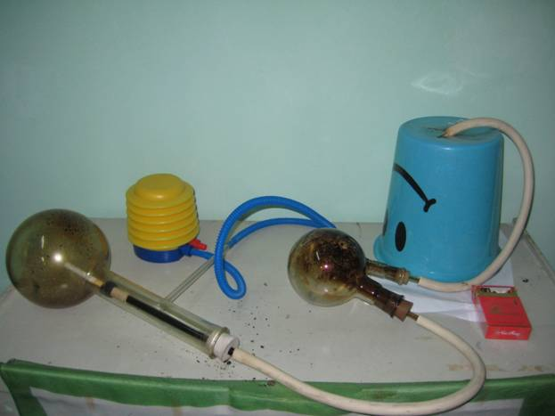
The Generator. The primary receptacle is a distiller flask. A glass tube is inserted through a rubber stopper. The glass tube is the length of the neck of the flask, and a very short rubber tube is attached to the internal end of the glass tube; the cigarette butt is inserted into and held by the rubber tube; the end of the cigarette is lit and is placed inside the flask. A simple accordion-style hand pump is attached to the flask’s narrow tube; pumping air into the flask forces the cigarette to burn and the smoke exits through the external glass tube.

发生器：起始容器是一个蒸馏烧瓶。一个玻璃试管从橡胶塞中插入其中，该玻璃试管的长试即为烧瓶瓶颈的长度，玻璃试管的末端内部塞有一个非常短小的橡胶塞，香烟的烟头部分就被固定在这个橡胶塞上，香烟的另一端在烧瓶内部点燃。一个简易的风琴式手动泵连接在烧瓶的小直径管上，将空气泵入烧瓶内部以供香烟燃烧直到烟扩散到外部玻璃试管。
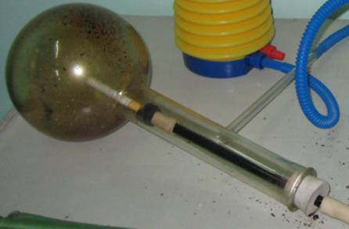
The Condenser. A lot of moisture is created as the tobacco burns, and if allowed to go through the system would drip on and stain the test paper. A simple glass sphere condenser is sufficient to catch excess moisture and allow the smoke to continue unimpeded. The receiving end is connected with a rubber tube to the flask’s stoppered glass tube. The other end of the condenser is a tube that runs to the collecting bucket.

冷凝器：香烟燃烧时会产生大量的水份，如果让水份通过整个系统将会沾湿并污染试纸。一个简单的玻璃球体冷凝器就可以充分过滤掉多余水份同时不使烟雾的扩散受到阻碍。它的接收端连接在蒸馏烧瓶内置试管的橡胶塞上，另一端是个试管连接到收集桶。
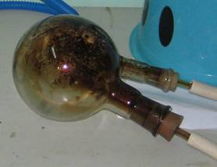

The Receiver. A simple bucket with a small hole in the bottom (even a flower pot will do!) receives the smoke. Its diameter at the top should be less than an A4 size of paper. The tube from the dry side of the condenser is placed just inside the hole in the bottom of the bucket from the bottom side, and the bucket is placed upside down centered on a piece of white index card stock sized A4.
收集器：一个底部有小孔的塑料桶（或者一个花盆）就可以收集烟雾。桶口直径应小于一张A4纸。桶底部由的小孔由外向内放置一个试管连接着冷凝器的干燥端，桶被倒置于上张白色A4纸上。

操作步聚：蓝色箭头代表空气流动方向，手动向蒸馏瓶中泵入空气，空气在使蒸馏瓶中的香烟燃烧后形成烟雾回流经冷凝器进入收集器。
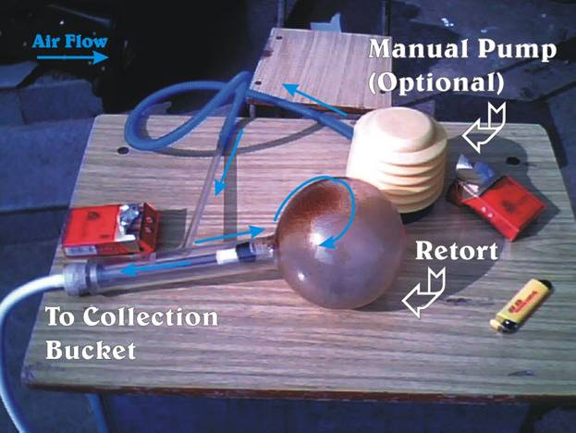
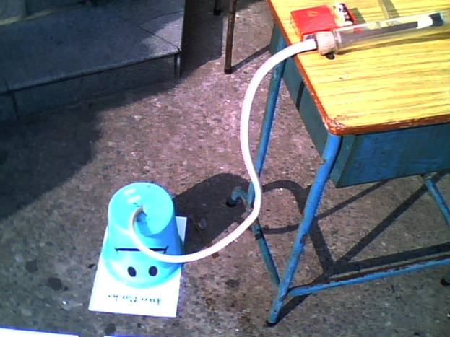

It is suggested that a prepared sampling of ½ pack, 1, 2 and 3 packs be made ahead of time. Doing one cigarette should be sufficient for public demonstration purposes, as it will be visible on the paper.
建议提前做好半包烟、1包、2包和3包烟的试验样版，因为结果都以图像的形式直观的体现在纸上，在公众面前进行一只烟的试验过程展示就足以说明问题。
It may also be instructive to prepare samples from different brands. The low tar brands, for example, do yield slightly lighter images, but still have considerable visual impact. For demonstration purposes, it may be useful to invite visitors to volunteer a cigarette for the demonstration.
准备不同品牌的香烟燃烧结果展示同样是有意义的。低焦油含量的品牌可能会产生略微清淡的图像，但仍然有很强的视觉冲击力。为了更好的起到说用作用，可以请现场观众提供一支烟进行演示。
1. WARNING!!! Ensure adequate ventilation!!! Latest research shows that the smoke from a single cigarette can kill. This experiment should be done only under a ventilator with sufficient negative flow that none of the smoke escapes. Hazmat procedures including protective gloves are recommended.
警告！！！确保现场有良好的通风！！！最新研究证实了一支香烟的杀伤力。所以以上实验必需要在有良好通风设备的场所，以确保没有实验中的烟雾会溢出。推荐使用有害物操作程序和保护手套。
2. Place a sheet of paper on a flat surface and place the bucket centered over the paper.
在平整的平面上放置试验纸张，在试验纸张上居中放置收集桶。
3. Place a cigarette butt securely into the internal tube and light the exposed end.
将香烟的烟头部分固定在内部方管中并点燃另一端。
4. Immediately place the cigarette assembly into the flask, being sure the stopper if firmly inserted.
将点燃的香烟立刻放到收集烧瓶中，确保塞子将收集器密封好。
5. Gently pump air into the flask. 徐徐地将空气泵入烧瓶。
CAUTION: : Pumping too fast will generate excessive heat!
提醒：泵入过快会产生过度的热量！
NOTE: It is normal for some smoke to seep out between the bucket and the paper.
提示：在桶和纸张中间很可能会有烟雾渗出。
6. Stop pumping when the cigarette has burned to within 0.5cm of the filter.
在香烟燃烧到距离烟头只有0.5厘米处停止泵入空气。
7. Remove the cigarette assembly from the flask, remove and extinguish the cigarette.
从收集器中取出香烟并熄灭。
8. Repeat Steps 3 through 7 if you are doing a multiple sampling.
如果要进行多重抽样就重复第3至第7步。
9. When the smoking procedure is completed, wait for at least one minute so the remaining smoke in the bucket can settle on the paper.
当烟雾产生已经完成，等候至少一分钟以使桶中的烟雾可以固定到纸张上。
10. Lift the bucket and remove the paper.
最后拿起桶并取出纸张。
WARNING!!! The smoke on the paper (“third-hand” smoke) is just as toxic and dangerous as second-hand smoke. Maintain adequate negative ventilation when handling the paper and avoid skin contact.
警告！！！纸张上的烟（“三手”烟）跟二手烟同样具有毒性和危害性。在展示时避免与皮肤直接接触并保证通风。
Results:
The sheets of paper are labeled with the quantity smoked and are displayed. The very important point to make is that if someone smokes the quantity shown on the sheet each day, then that is the amount of smoke that enters their lungs each day!
结论：纸张上注明香烟的数量后展示。重要的一点是如果将某人每日吸烟的数量展示在纸张上，那就是他每摄入到肺中的烟量。
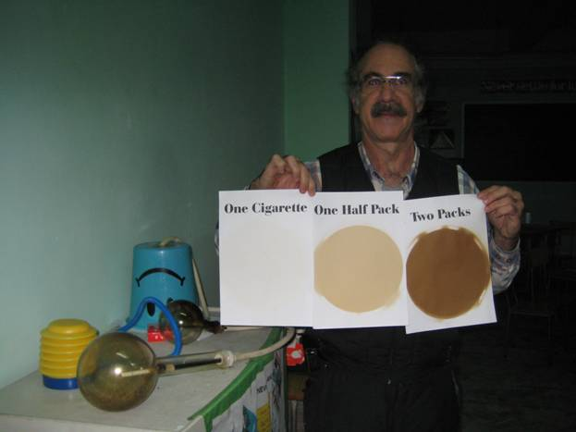
If this is of further interest, I would be delighted to meet with you and assist in any way with the planning. I expect no compensation other than to see the People in my new country have healthier, more prosperous lives.
如果您对以上内容感兴趣，我非常乐意与您面谈，会面的计划可由您来安排。我不期待任何的回报，可希望在我的新国家里人们可以更健康更有活力。
This is truly science at its best.
这是正真的科学。

Peace,

Don
11 September 2024
Don “Orfeo” Rechtman (唐瑞民)
Star Pavilion, Phase II, Wanshida Mingyuan, Taining Road, Luohu District, Shenzhen, Guangdong, China 518001
广东省深圳市罗湖区太宁路万事达名苑二期明星阁
518001
Phone (China): (+86) 135-2889-6144
Weixin (WeChat) name: oorfeo
don@orfeomusic.org

